Chapter 11, Solution 4.

Using Fig. 11.36, design a problem to help other students better understand instantaneous and average power.

Although there are many ways to work this problem, this is an example based on the same kind of problem asked in the third edition.

Problem

Find the average power dissipated by the resistances in the circuit of Fig. 11.36. Additionally, verify the conservation of power. Note, we do not talk about rms values of voltages and currents until Section 11.4, all voltages and currents are peak values.

5 Ω
+
–

20∠30º V j4 Ω 8 Ω

–j6 Ω

Figure 11.36 For Prob. 11.4.

Solution

We apply nodal analysis. At the main node,

I₁ 5 Ω I₂
V_{o}
+
–

20∠30º V j4 Ω 8 Ω

–j6 Ω

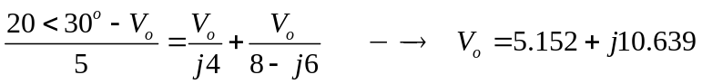= 11.821∠64.16˚
For the 5-Ω resistor,
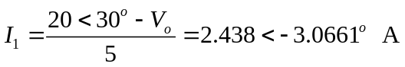
The average power dissipated by the resistor is
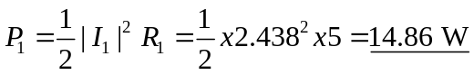

For the 8-Ω resistor,

I₂ = V_{o}/(8–j6) = (11.812/10)∠(64.16+36.87)˚ = 1.1812∠101.03˚ A

The average power dissipated by the resistor is

P₂ = 0.5|I₂|²R₂ = 0.5(1.1812)²8 = 5.581 W

The complex power supplied is

S = 0.5(V_{s})(I₁)* = 0.5(20∠30˚)(2.438∠3.07˚) = 24.38∠33.07˚

= (20.43+13.303) VA

Adding P₁ and P₂ gives the real part of S, showing the conservation of power.

P = 14.86+5.581 = 20.44 W which checks nicely.

